Salesman Analysis

**Aim of Project**

The Salesman Analysis Project aims to provide insights and optimize the performance of sales representatives within a company. This project involves collecting, processing, and analyzing various data related to sales activities, customer interactions, and performance metrics of salesmen.

The objective of this project is to conduct a comprehensive analysis of sales data to gain valuable insights into the performance of our sales team and identify areas for improvement. By leveraging data analytics, we aim to enhance decision-making processes, optimize sales strategies, and ultimately increase revenue.

**Representation of this project:-**

**Database Name: sales_analysis**

**Show the table structure of Sales Team:**

**Query:**

**SELECT * FROM sales_man;**

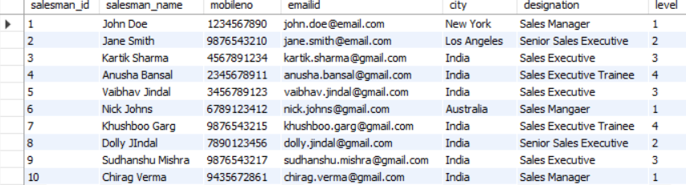

**Show the table structure of Brands:-**

**Query:**

**SELECT * FROM brand;**

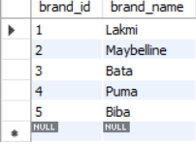

**Show the table structure of Categories:-**

**Query:**

**SELECT * FROM category;**

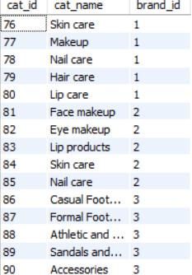

**.................so on**

**Show the table structure of Product:-**

**Query:**

**SELECT * FROM product;**

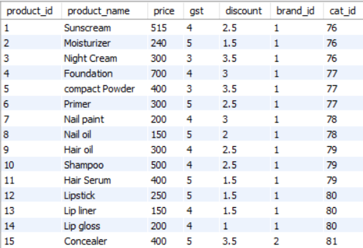

**...........so on**

**Show the table structure of Order_table:-**

**Query:**

**SELECT * FROM order_table;**

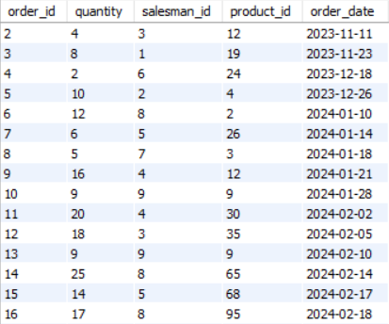

**.........so on**

**Questions:**

1. Show the all salesman.

**Query:**

**SELECT * FROM sales_man;**

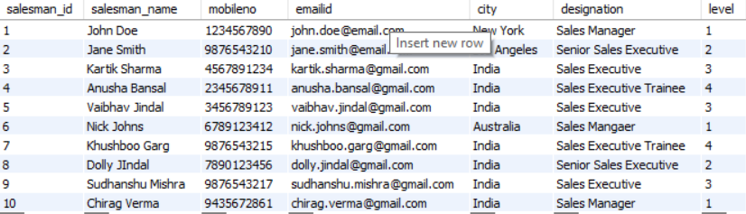

1. Show all brands.

**Query:**

**SELECT * FROM brand;**

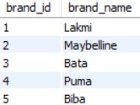

1. Show all category with brand.

**Query:**

**SELECT c.cat_id, c.cat_name, b.brand_name**

**FROM category as c**

**LEFT JOIN brand as b**

**ON c.brand_id=b.brand_id;**

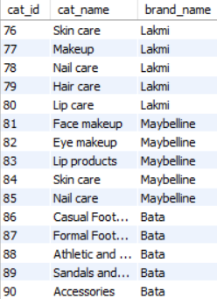

........so on

1. Show all product with brand and category.

**Query:**

**SELECT p.product_id, p.product_name, b.brand_name, c.cat_name**

**FROM product as p**

**LEFT JOIN brand as b**

**ON p.brand_id=b.brand_id**

**LEFT JOIN category as c**

**ON p.cat_id=c.cat_id;**

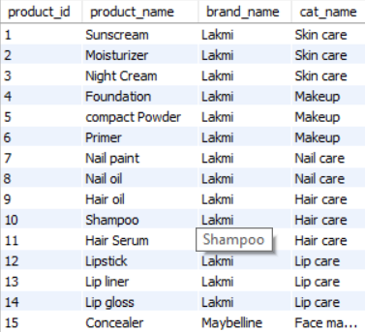

**.........so on**

1. Show the number of product for each brand.

**Query:**

**SELECT b.brand_name,count(p.product_id) as total_product**

**FROM product as p**

**join brand as b on p.brand_id=b.brand_id**

**group by b.brand_id;**

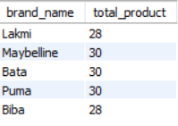

1. Show the number of product for each brand and category.

**Query:**

**SELECT b.brand_name, c.cat_name, count(p.product_id) as total_product**

**FROM product as p**

**LEFT JOIN brand as b**

**ON p.brand_id=b.brand_id**

**LEFT JOIN category as c**

**ON p.cat_id=c.cat_id**

**GROUP BY b.brand_id, c.cat_id;**

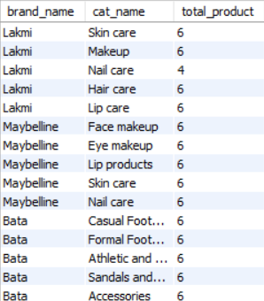

7) Show the order each salesman with product name brand and category and order amount as well.

**Query:**

**SELECT o.order_id, s.salesman_name, p.product_name,**

**b.brand_name, c.cat_name,(p.price*o.quantity) as order_amount**

**FROM order_table as o**

**JOIN sales_man as s ON o.salesman_id=s.salesman_id**

**JOIN product as p ON o.product_id=p.product_id**

**JOIN brand as b ON p.brand_id-b.brand_id**

**JOIN category as c ON p.cat_id=c.cat_id**

**order by s.salesman_id ASC;**

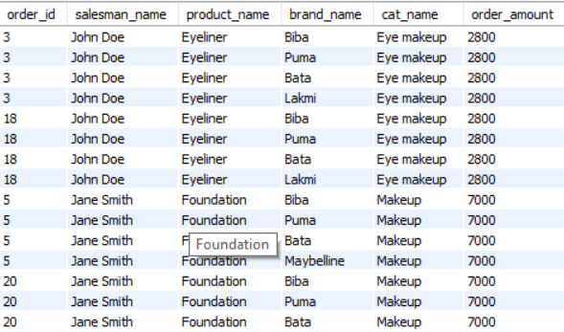

8) Show the number of order for each salesman with brand.

**Query:**

**SELECT s.salesman_id, s.salesman_name, b.brand_name, COUNT(o.order_id) as order_total**

**FROM order_table as o**

**JOIN sales_man as s**

**ON o.salesman_id=s.salesman_id**

**JOIN product as p**

**ON o.product_id=p.product_id**

**JOIN brand as b**

**ON p.brand_id=b.brand_id**

**GROUP BY s.salesman_id, b.brand_id;**

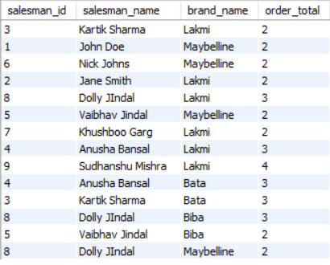

9) Show the number of order for each salesman with brand and category.

**Query:**

**SELECT s.salesman_id, s.salesman_name,**

**b.brand_name, c.cat_name, COUNT(o.order_id) as total_order**

**FROM order_table as o**

**JOIN sales_man as s ON o.salesman_id=s.salesman_id**

**JOIN product as p ON o.product_id=p.product_id**

**JOIN brand as b ON p.brand_id-b.brand_id**

**JOIN category as c ON p.cat_id=c.cat_id**

**GROUP BY s.salesman_id, b.brand_id, c.cat_id;**

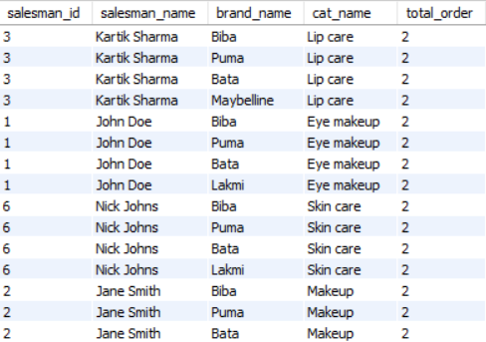

10) Show the total order amount for each salesman with sold order quantity and product name.

**Query:**

**SELECT s.salesman_id, s.salesman_name, p.product_name,**

**Sum(o.quantity*p.price) as total_order_amount, sum(o.quantity) as quantity**

**FROM order_table as o**

**JOIN sales_man as s ON o.salesman_id=s.salesman_id**

**JOIN product as p ON o.product_id=p.product_id**

**GROUP BY s.salesman_id, p.product_id;**

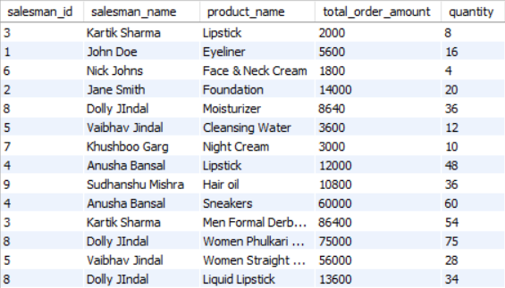

11) Show the total order amount for each salesman and brand.

**Query:**

**SELECT s.salesman_id, s.salesman_name, b.brand_name, sum(p.price*o.quantity) as total_order_amount**

**FROM sales_man as s**

**JOIN order_table as o ON s.salesman_id=o.salesman_id**

**JOIN product as p ON o.product_id=p.product_id**

**JOIN brand as b ON p.brand_id=b.brand_id**

**GROUP BY s.salesman_id, b.brand_id;**

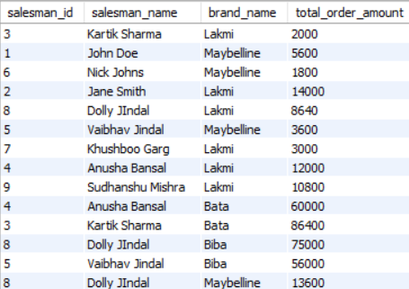

12) Show all order accordingly to most popular brands.

**Query:**

**SELECT b.brand_name, SUM(o.quantity) as quantity**

**FROM order_table as o**

**JOIN product as p ON o.product_id=p.product_id**

**JOIN brand as b ON p.brand_id=b.brand_id**

**GROUP BY b.brand_id**

**ORDER BY SUM(quantity) DESC;**

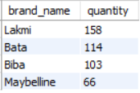

In conclusion, the Sales Performance Analysis project has equipped us with actionable insights and strategic recommendations to propel our sales team to new heights. As we embark on the implementation phase, we remain committed to data-driven decision-making and a culture of continuous improvement.